Bread Financial’s main business line is credit cards. The company partners with retailers to issue private label and co-branded cards and manages the complete card lifecycle, from origination and transactions to billing and collections
1.1 Credit Cards (Core Business)
- Bread is primarily a card issuer and servicer.
card life cycle checks and track
- Issues cards on behalf of retail partners.
- Manages the entire card lifecycle:
  - Application and underwriting
  - Authorization and transactions
  - Billing and payments
  - Collections and charge-offs
  - Customer servicing and disputes
Example:
A customer applies for a Victoria’s Secret card.
- Frontend brand is the retailer.
- Backend credit decisioning, account management, and collections are handled by Bread. – card life cycle checks and track

1.2 Loans (BNPL / Bread Pay)
Bread also offers short-term installment loans under Bread Pay.
- Used for “Pay Over Time” or EMI-style purchases.
- Typically smaller ticket sizes. ----
- Integrated at checkout for partner merchants.
Example:
A customer purchases a $1,200 product and selects a 6-month Bread Pay plan.
Bread:
- Approves the loan
- Disburses funds to the merchant
- Collects installments from the customer

1.3 Deposits (Savings Products)
Bread operates regulated banking entities:
- Community Bank
- Community Capital
These support:
- Savings accounts
- Funding for lending and credit products
Example:
Customer deposits are used as part of Bread’s funding strategy while complying with banking regulations.
Around 19 well-defined data marts.
Majority focused on credit card business lines.
Let me walk you through the Types of Credit Cards Issued by the Bread
2. Types of Credit Cards Issued
Bread primarily issues two categories of cards.
2.1 Private Label Credit Cards (PLCC)
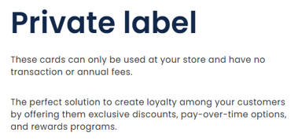
Definition:
Cards that can be used only at the issuing retailer.
Characteristics:
- No Visa/Mastercard network
- Store-restricted usage
- Strong loyalty and discount programs
- Lower interchange costs
Example:
- The Children’s Place card
- Can only be used at Children’s Place stores or website
Business Value:
- Drives repeat purchases
- Increases customer retention for retailers
- Lower fraud exposure
2.2 Co-Branded Credit Cards

Definition:
Cards issued jointly with a retailer and a payment network (Visa/Mastercard).
Characteristics:
- Can be used anywhere the network is accepted
- Earns both:
  - Brand-specific rewards
  - Network benefits
Example:
- NFL Visa card (New York Football Legue)
- Can be used at grocery stores, travel, online shopping, etc.
Business Value:
- Higher transaction volume
- Better customer lifetime value
- Broader spending data for analytics
PLCC vs Co-Branded (Quick Contrast)
Aspect | PLCC | Co-Branded
Usage | Store only | Anywhere
Network | None | Visa/Mastercard
Rewards | Store-specific | Store + Network
Risk | Lower | Higher but diversified
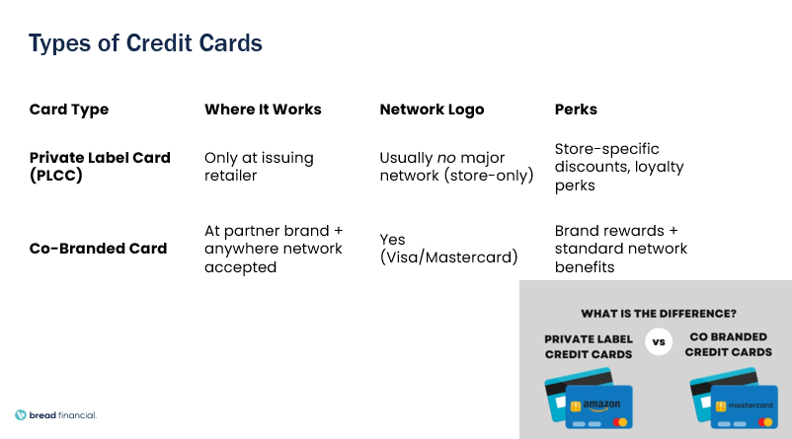

3. Enterprise Data Architecture
The move from Pre-Fiserv to Post-Fiserv transformed the data platform from a legacy, ETL-heavy environment into a standardized, scalable, and governance-driven architecture focused on credit card analytics.
Pre-Fiserv & Post-Fiserv –
1)Fiserv is basically a data provider for Bread. Before June 2022, we were not getting data from Fiserv rather Bread had an in-house data source which comes from Mainframes or DB2. Old or Governed Marts were built using this data.
Later this was found to be not reliable as Bread’s data would come in a single file, and downstream teams would build queries on it to consume data. Bread started acquiring data from Fiserv to ensure reliability and current marts listed above are built on Fiserv data.
The transition from the pre-Fiserv to post-Fiserv architecture enabled Bread Financial to move from a fragmented, ETL-heavy environment to a standardized, scalable, and governance-driven data platform focused on credit card analytics.
Pre-Fiserv, the architecture was more fragmented, batch-driven, and tightly coupled to legacy systems, making enhancements slower and harder to scale.
Post-Fiserv, the architecture is standardized around Fiserv, cloud-based, and modeled for historical tracking, allowing faster onboarding, better governance, and scalable credit card analytics.

Area | Pre-Fiserv | Post-Fiserv
Business Focus | Multiple products with mixed focus | Predominantly credit card–centric
Primary Card Processor | Multiple legacy and vendor systems | Fiserv as single primary processor
Source System Structure | Disparate, heterogeneous sources | Standardized Fiserv feeds
Data Ingestion | Mostly batch (daily / monthly files) | Daily batch + selective near real-time
Feed Standardization | Low – custom formats per source | High – consistent schemas and delivery
EDW Platform | Traditional relational EDW | Cloud-based scalable EDW
Data Modeling | Star / Snowflake schemas | Data Vault / Hybrid modeling
Change Impact | High impact across marts | Isolated changes with minimal downstream impact
Historical Tracking | Limited or complex | Built-in historization
Data Marts | Less standardized, logic duplication | ~19 governed, conformed marts
Credit Card Coverage | Partial and fragmented | ~99% of marts focus on card data
Business Logic | Embedded in ETL pipelines | Centralized and reusable
Enhancement Effort | Time-consuming and manual | Faster and structured
Governance & Security | Basic access controls | RBAC, PII masking, compliance ready
Release Cycle | Monthly or ad-hoc | Quarterly with priority exceptions
Operational Stability | Higher regression risk | Predictable and stable releases
Scalability | Limited | High and elastic

In the earlier EDW setup, data mainly came from on-premises systems, with DB2 being the main source. All business data such as transactions, account changes, and customer details was first copied into DB2 staging tables. This staging area acted as a temporary holding layer. It protected the source systems from reporting load and allowed basic data checks before the data moved further.
After the data reached the staging layer, batch programs controlled by shell scripts processed it. In this step, the data was cleaned, transformed, and updated based on business rules. Once processing was complete, the data was loaded into the Enterprise Data Warehouse running on Yellowbrick. This warehouse stored the data in structured tables that could be used for reporting and analysis.
From the EDW tables, different data marts were created for specific business areas such as Accounts, Transactions, and Cardholders. These data marts contained ready-to-use business metrics. Final users did not access tables directly; instead, they used predefined EDW views, which simplified access and kept reporting consistent. These views sent data to downstream systems like CPM, EDH, and reporting databases. Business users then accessed the data using tools such as MicroStrategy, Tableau, SAS, and Python. Since the entire process was batch-based and tightly connected, making changes or enhancements took more time and effort.

In the current EDW setup, the data flow is more organized and mainly focused on credit card data. Data now comes from two sources: the existing DB2 systems and Fiserv, which is the main card processing system. Fiserv provides standardized data for accounts, transactions, authorizations, fraud, and statements. Data from both DB2 and Fiserv is first loaded into staging areas using Informatica, where basic checks like structure validation and data completeness are performed.
After staging, the data is moved into the Yellowbrick EDW, which continues to be the central system for analytics. Inside the EDW, data from all sources is combined and aligned so that it is consistent across business areas. Standard enterprise data marts and smaller subject-specific marts are then built on top of this data. This approach avoids repeating logic and makes development faster. All downstream systems access data only through approved EDW views, which ensures consistent definitions, controlled access, and proper governance.
From these EDW views, data is shared with downstream platforms such as CPM, EDH on Azure, SSA, CARE, and Bounty based on business needs. At the same time, outbound files and direct feeds are created for Python, SAS, or external reporting requirements. End users finally consume this data using reporting and analytics tools, with access controlled by user roles. Compared to the earlier setup, the current architecture is more scalable, easier to manage, faster to enhance, and provides a clearer and more stable flow of data from source systems to business users.

